Donjon’s Algorithm
http://donjon.bin.sh/dungeon/about/
A very, very flexible algorithm with an explanation and Perl source. Dungeons can look similar to this example or not at all, there’s a lot of variety.
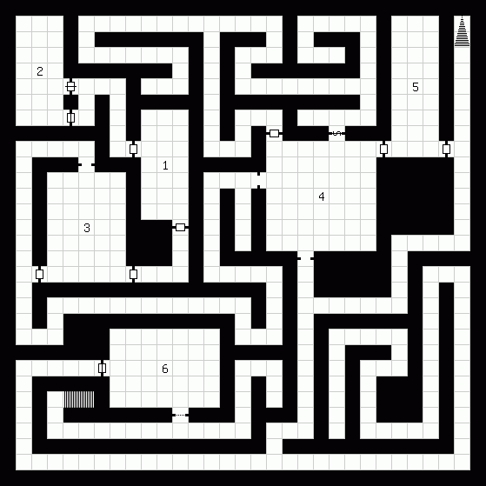

BSP Algorithm
http://roguebasin.roguelikedevelopment.org/index.php?title=Basic_BSP_Dungeon_generation
This one looks really easy to implement. Could be good for a first try!

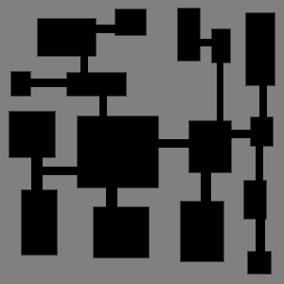

Tyrant(?) Algorithm
http://roguebasin.roguelikedevelopment.org/index.php?title=Dungeon-Building_Algorithm
Also very simple to implement. Uses chunks that connect together. URL has Java/Processing source!

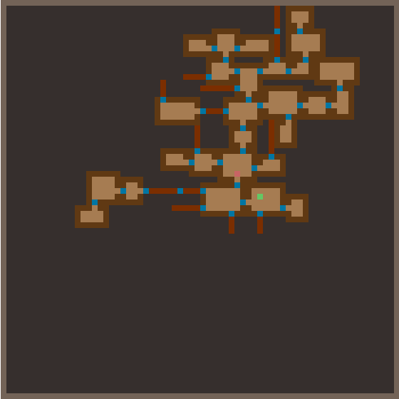

Unangband Algorithm
http://roguelikedeveloper.blogspot.com/2007/11/unangband-dungeon-generation-part-one.html
http://roguelikedeveloper.blogspot.com/2007/11/unangband-dungeon-generation-part-two.html
Haven’t really looked at it much. In part 2 the guy actually says it’s boring though… probably out of context though. Looks a bit corridor-heavy.
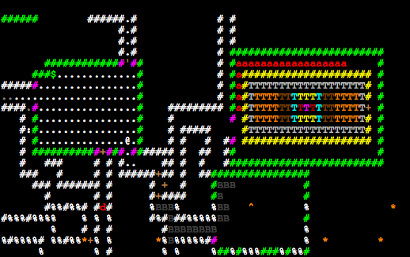

Fractal Algorithm
http://roguebasin.roguelikedevelopment.org/index.php?title=Fractals
Fractals are ridiculous, they can do anything. Apparently they’re good at creating blobby, amoeba-like rooms…
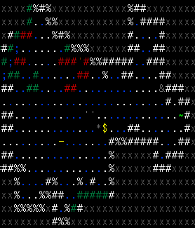
(from http://roguelikedeveloper.blogspot.com/2007/11/unangband-dungeon-generation-part-five.html)

Diffusion-limited Aggregation Algorithm
http://roguebasin.roguelikedevelopment.org/index.php?title=Diffusion-limited_aggregation
…the fuck is this? Looks too corridor-y for our tastes anyway.
############################################################
###############################################.############
######################################.########.############
###################################....########.############
######################################.########.############
###########...########################........#.############
###########......###################....####....############
###########.#####......###############.######.##############
###########.######.##########################.##############
###########.######.################.....##....##############
###########.#.####.#################.#.....##.##....###.....
###########.#.####.############.#.##.########.####.##.#.####
###########.#.####.############.#.##.....####.####.#..#.####
##########....#.#.#############.#.##..#######.####.#....####
#############.#.#.###.#########.#.##..#######.###....#..####
#############.#.#.###.##......#....#..#######.###..#.#...###
#############.#.#.###.########.........##########..###.#.###
#############.......#.##.......#...##........####..###....##
#############.######......#####.......######.####.####....##
#############.######...########...##########.####.####....##
#############.######...########...#.....###...............##
#############.##........####.##...###.#####.#####..#####..##
########.......#.....#.#####.##.#####.#####.#####..#.####.##
###############....#.......#.##.##.##.#####.####.....#######
####################.##.###..........####....#######.#######
####################.##.###.....#..#.###.#.......###.#######
#######################.#####........###.###########.#######
#######################......####....###.###########.#######
#######################.####.........###.###########.#######
############################.#####...###############.#######
############################.#####....##############.#######
############################.#####.#..##############.#######
############################.#####.#..##############.#######
############################.###......####.#################
#############################...##.#...###.#################
###########################........##...##.#################
##################################.####......###############
##################################.#########################
################################....########################
############################################################

dMap Algorithm
http://roguebasin.roguelikedevelopment.org/index.php?title=Dungeon_builder_written_in_Python
Hey! This one looks promising! Lots of rooms and not terribly many corridors! Has Python source.
######
### #....#
#.# #.####
#.# ########### #.#
######.# ################.........# #.#
#...##.# #......=.......=.........# #.#
###...##.# ##############=#.........# #.#
#.=...##.############## #.#.........#### #.#
#.#...##.=............# #.#.........##.# #.#
#.#...####=#=########.##########.#.........##.####### #.#
#.##### #....=.................#.#.........##.#.....# ###.########
#.# ######################.#.####=#######.#.....# #.#.#......#
#.################# #.#.# #.......=.......# #.#.=......#
#.##..............# #.#.# ###########.....# #.=.#......#
#.############=##.###### ####.#.# ####### ###.#########
#.#....=.......#.......# #.##.#.# ############ #.........#
##=####=#.#######.......# #.##.#.# #..........# #.#########
#..........# #.......# #.##.#.####.####=#...# #.=....#
###########=######.......# #.##.#.#....# #.#...# #......#
#......##................# #.##.#.#....# #.#...# #.#....#
#=####.##........#.......# #.##.#=#....# #.=...# #.######
#.......#........#.......####=##...=....# #=#...# #.#
#.......=........#.......##...##.#.=....# #.#...# #.#
#................#.......##.####.=......# #.#...######### #.#
#.......#........##########....#.#.#....# #.#...=.......# #.#
#................##########....=.#.#=#### #.....######### #.#
#.......###########......##....#.=.#...# #=################=###
###=###############=####=##....#.#.##### #....................#
#..........=...................#.#.################################
#.###.###=###########=.####....#.#....................# #.......#
#.# #........# #.....##....###...################=#####.......#
#.# #........### #.....##....# #...# ########.........#.......#############
#.# #........=.# #.....##########.######......#.........#.......#...........#
#.# #........#.# #...........=.........=................#.......#.###########
#.# #........#.# #.....#######..........................=.......#.........#
#.# #........=.# #.....# #.........#......#.........#.......#.........#
### #........#.# #.....# #.........#......#=#######.#.................#
#........### ####### #.........#......#.........#.......###########
########## #################################### (from http://roguebasin.roguelikedevelopment.org/index.php?title=Dungeon_builder_written_in_Python/Examples)
Jamis Buck’s Algorithm
http://petosky.net/node/4
Pretty huge, snake-like corridors. Idk, looks kind of boring to me. Can’t find source either…


Gozzy’s Algorithm
http://diceofdoom.com/blog/2008/08/online-random-dungeon-creators/
Who knows how it works? It is a mystery…
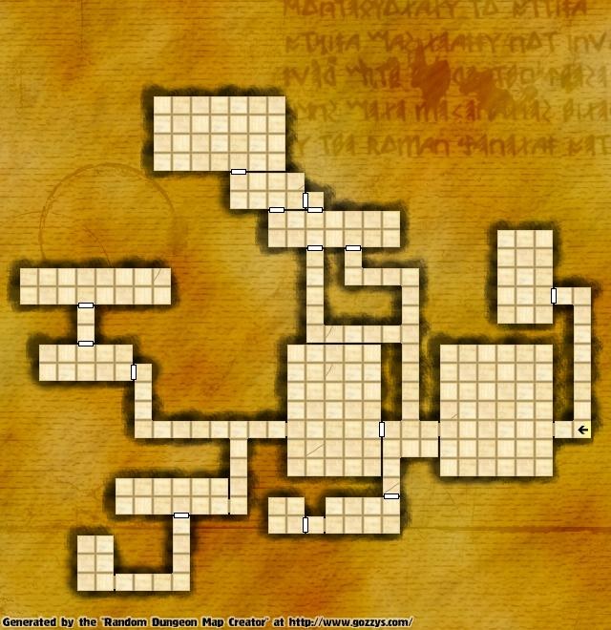

Incursion: Halls of the Mountain King Algorithm
http://www.gamesetwatch.com/2008/12/28-week/ (this is just where I found the screenshot)
Looks neat. I like it, lots of contrast between corridors and big open areas.
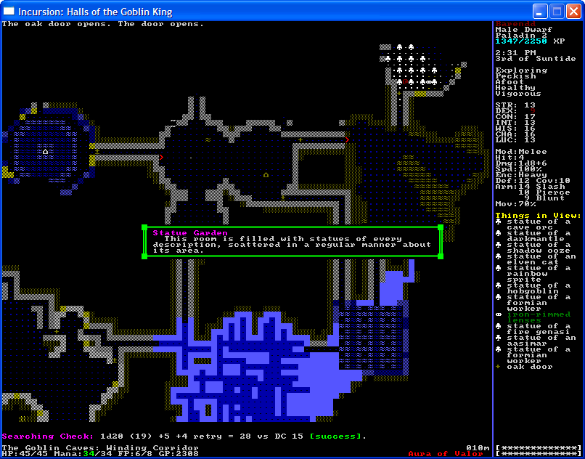

DungeonGen Algorithm
http://martiniland.net/dungeongen.php
Wow. Look at that fucking screenshot.
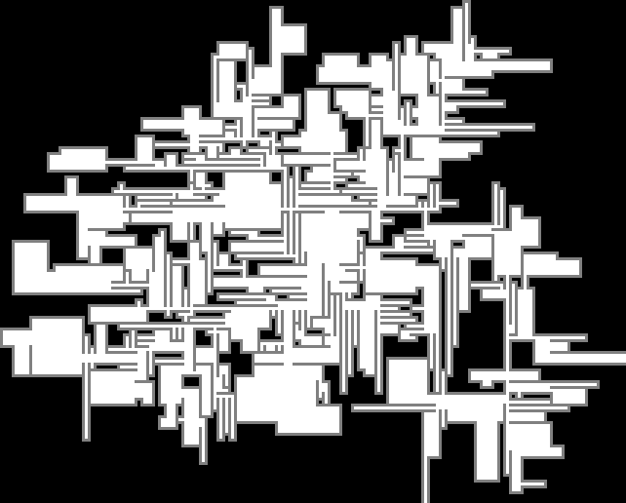
I mean just fucking look at it.

Has python source.

Josh Tippett’s Algorithm
http://members.gamedev.net/vertexnormal/tutorial_randlev1.html
A tutorial that uses ¾ view, like our game! Lots of big, open rooms, too. Looks kinda bland though imo, not enough separation between the rooms. Uses lua scripts.
